**Red hat**

Linux – OS interface between end user and machine ,24 x 7 – 365 days. Open source

GPL – General public License, if any tool released under GPL , no guarantee.

Closed- guarantee and paid support service

Red hat enterprise takes Linux open source (known as fedora) and provide warranty and guaranty.

It is a 3rd party responsibility to support and fix issues of open source Linux , RHEL

3 month release cycle two variants server and client,

Red hat enterprise offer support contract for 1-7 years of release and 24 x 7 support is also aavailable.

Sells support not product

**Linux**

Software and source code is available to all, Free software foundation and four freedoms

1984 – created open source of Unix utilities

1991 – Linus Torvalds, created open source ,Unix like kernel .Ports some GNU utilities .

Today – Linux kernel + GNU utilities = complete Unix like OS

**Red hat distribution**

Patching – fixes , updates

Red hat enterprise –stable, thoroughly tested, centralized management tools for large networks, professional support service.

Fedora project – new applications, community supported, for personal systems.

**Principles of Linux**

Everything is a file (hardware).

Small, single- purpose programs

Avoid captive user interface. No GUI

Ability to chain programs together to perform complex tasks

Configuration data stored in text.

**Username:** osboxes  
**Password:** osboxes.org  
**Root Account Password:** osboxes.org  
**VB Guest Additions & VMware Tools:** Not Installed  
**Keyboard Layout:** US (Qwerty)  
**VMware Compatibility:** Version 10+

**Virtualization**

Desktop – Host on top we will have virtualization.

oracleVB,VMware workstation

Bare metal – hypervisor (directly we can install virtualisation software)

IP 192.168.56.1

SSH login to remote linux host

Syntax- command – option arguments

DOCs.redhat.com

Inodes in linux- Physical address on disk

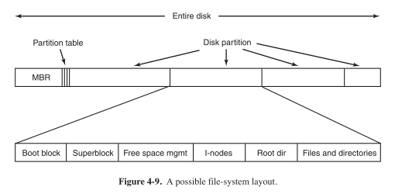

**Metadata :** information of data – indexing of data

**Descriptive metadata** -- changes with photo, london, goa, kerala, home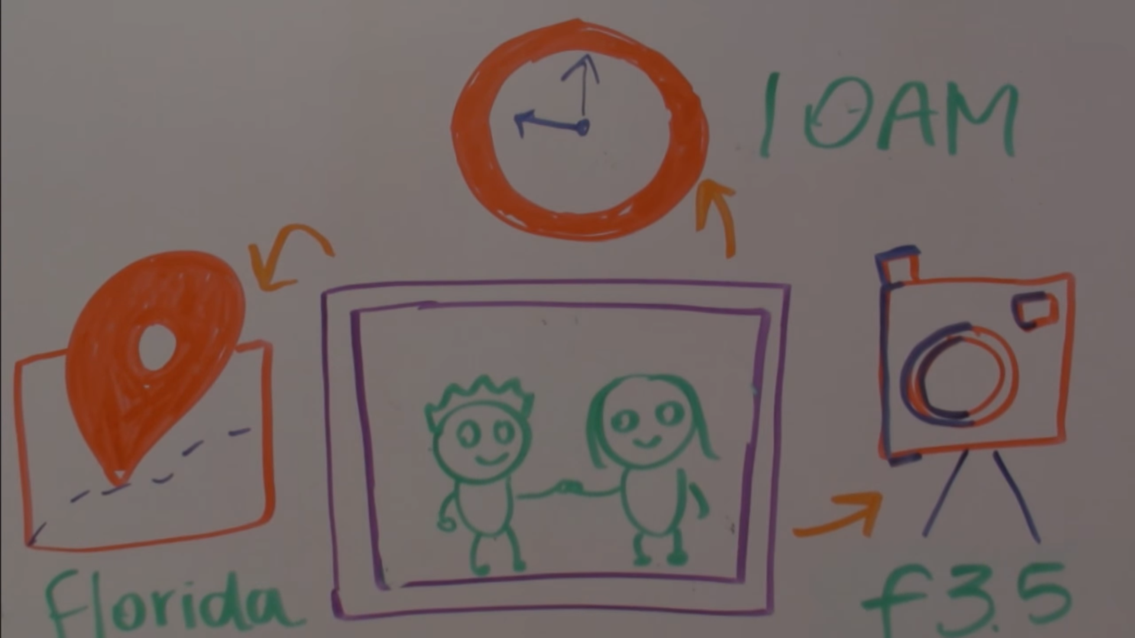

One file

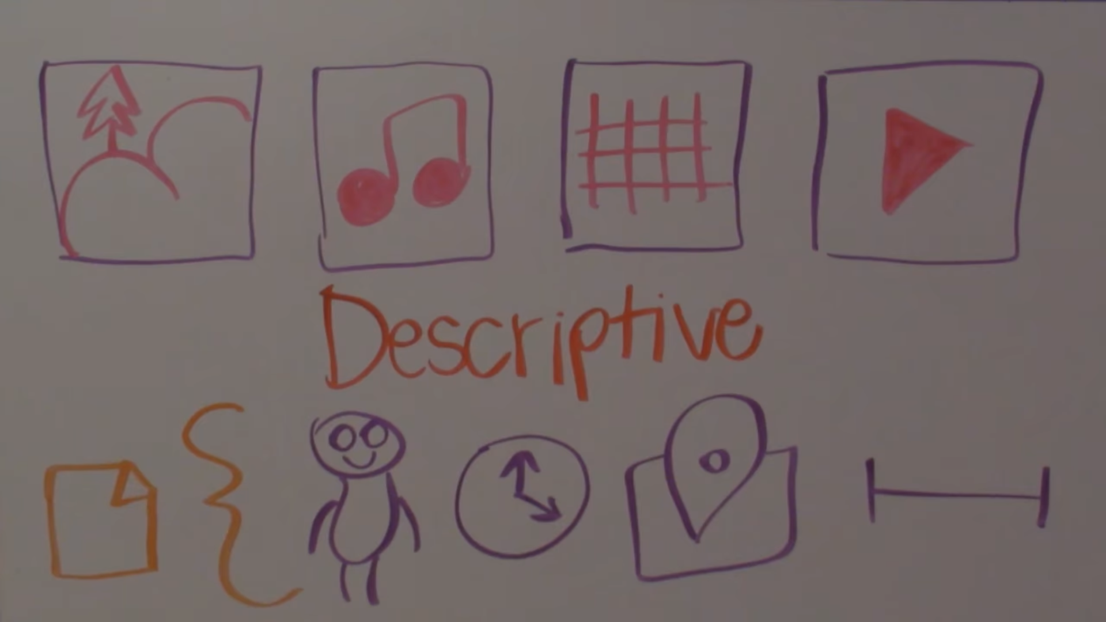

**Structural metadata :** table with all details of photo place,time, photo exposure time

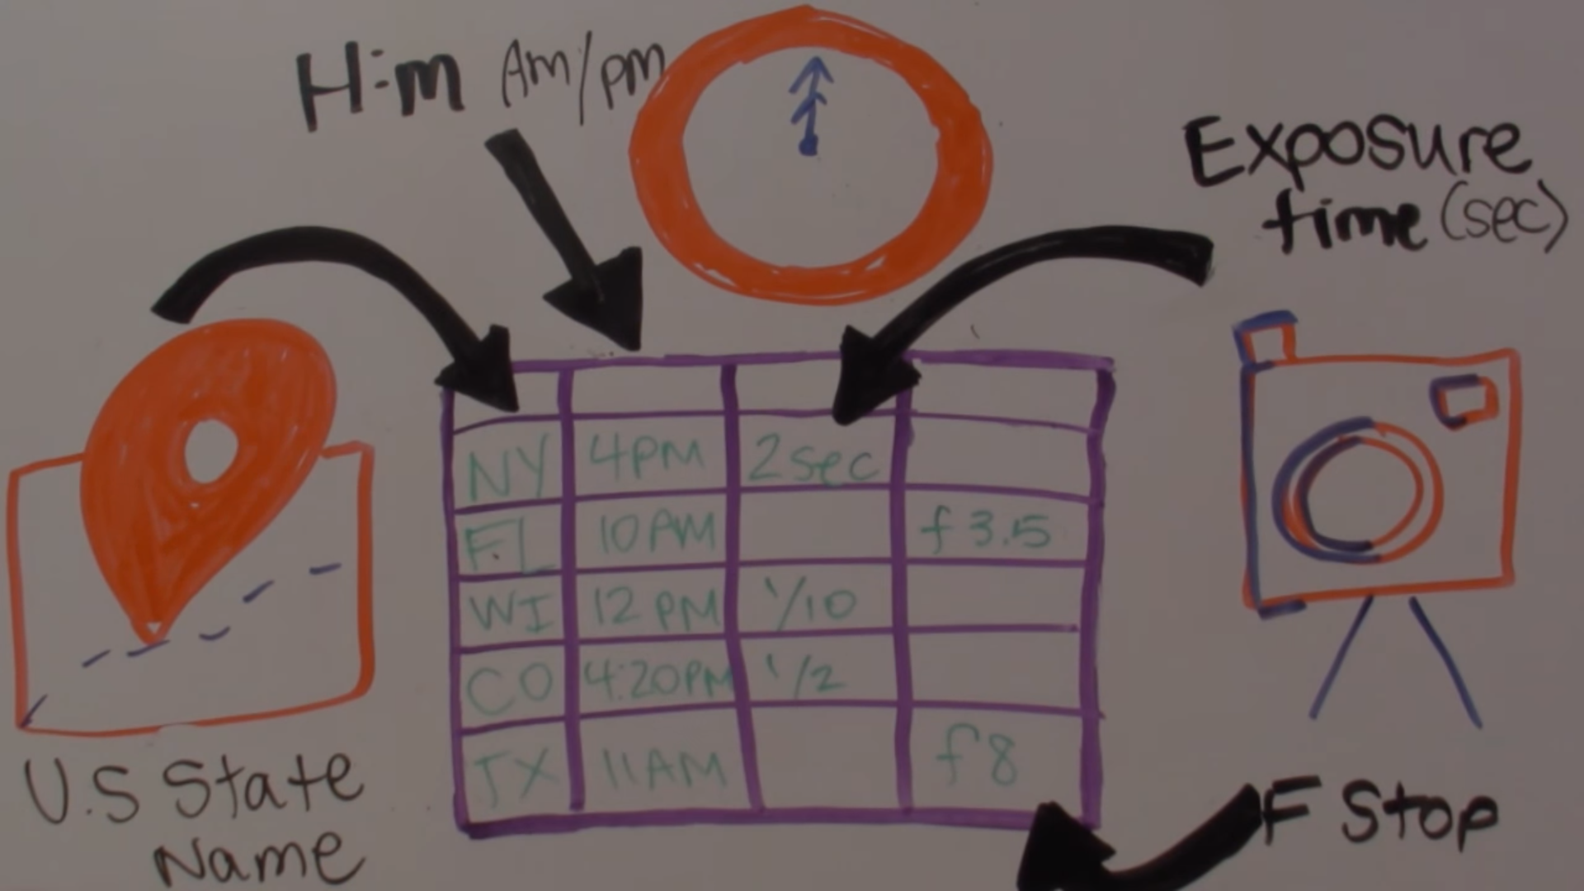

**Mutliple files with what does fields mean**

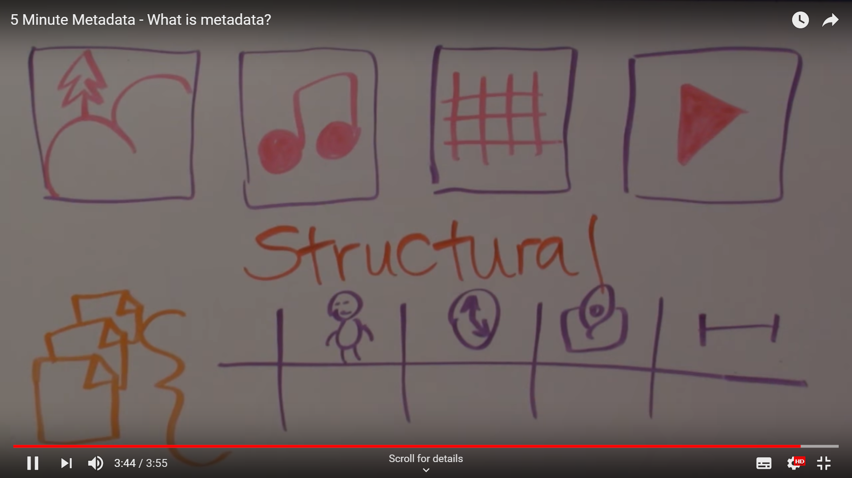

Linux filesystem is based on inode entries , this inodes holds metadata about the files

Inode :

Size

Device id

Uid

Gid

Mode

Timestamps

Pointer to data

--------------------------------------

Filename is stored seperatly with inode number linking to the metadata that represents the file.

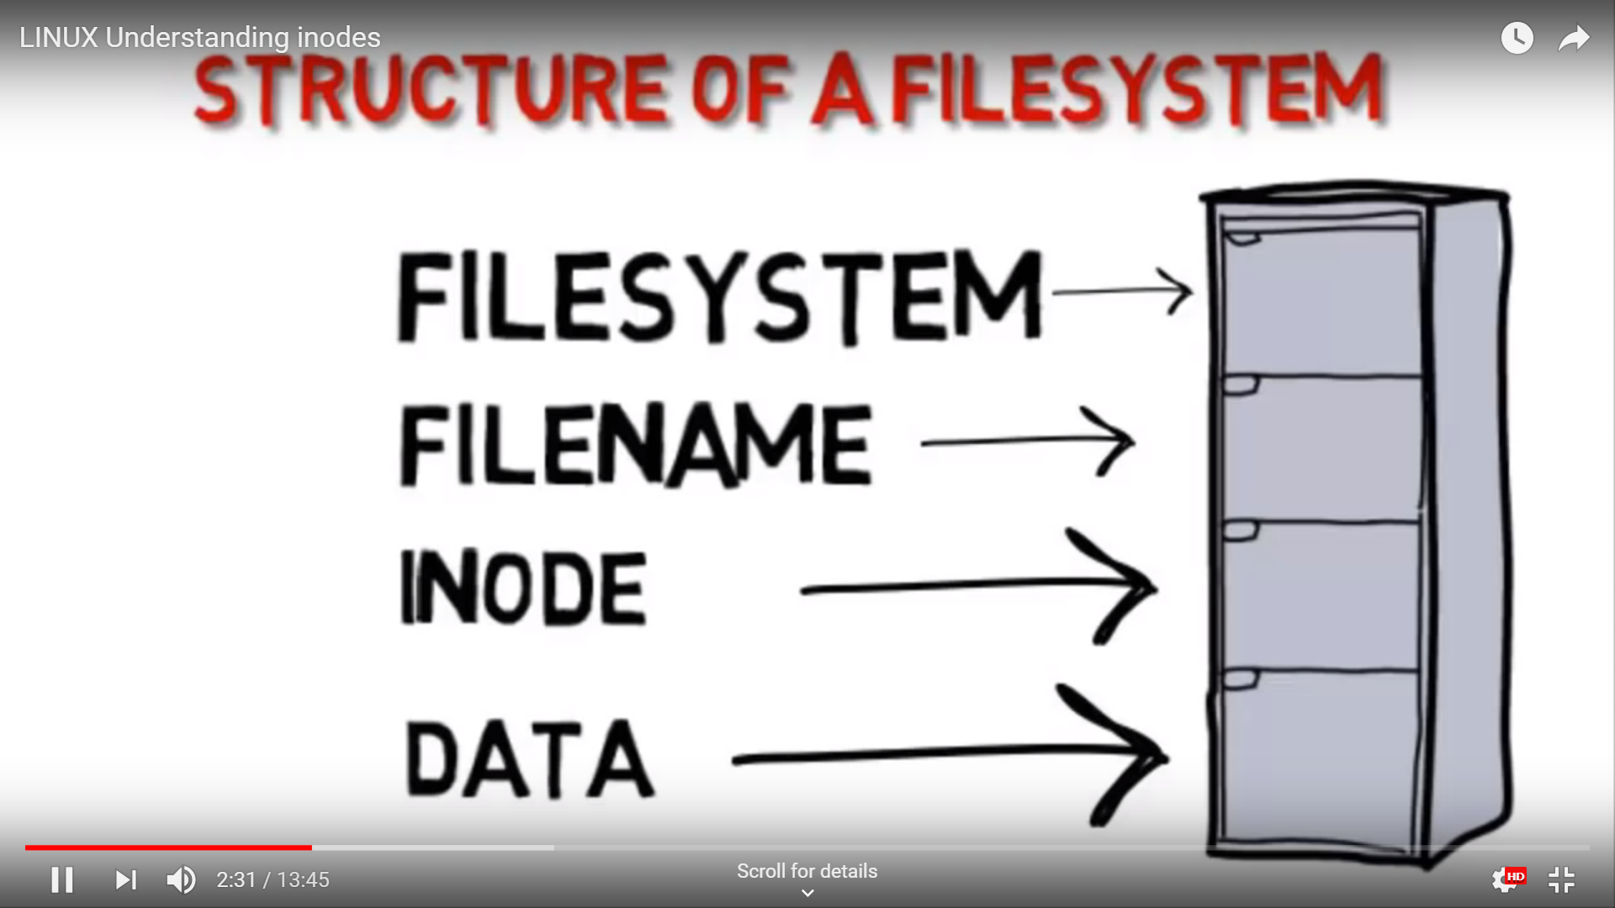

Filesystem will have file name -> Inodes -> physical data

File table will have filename and inode

Ls –i

498**** f1

Change and modify the file – we will modify size(this is stored in inode)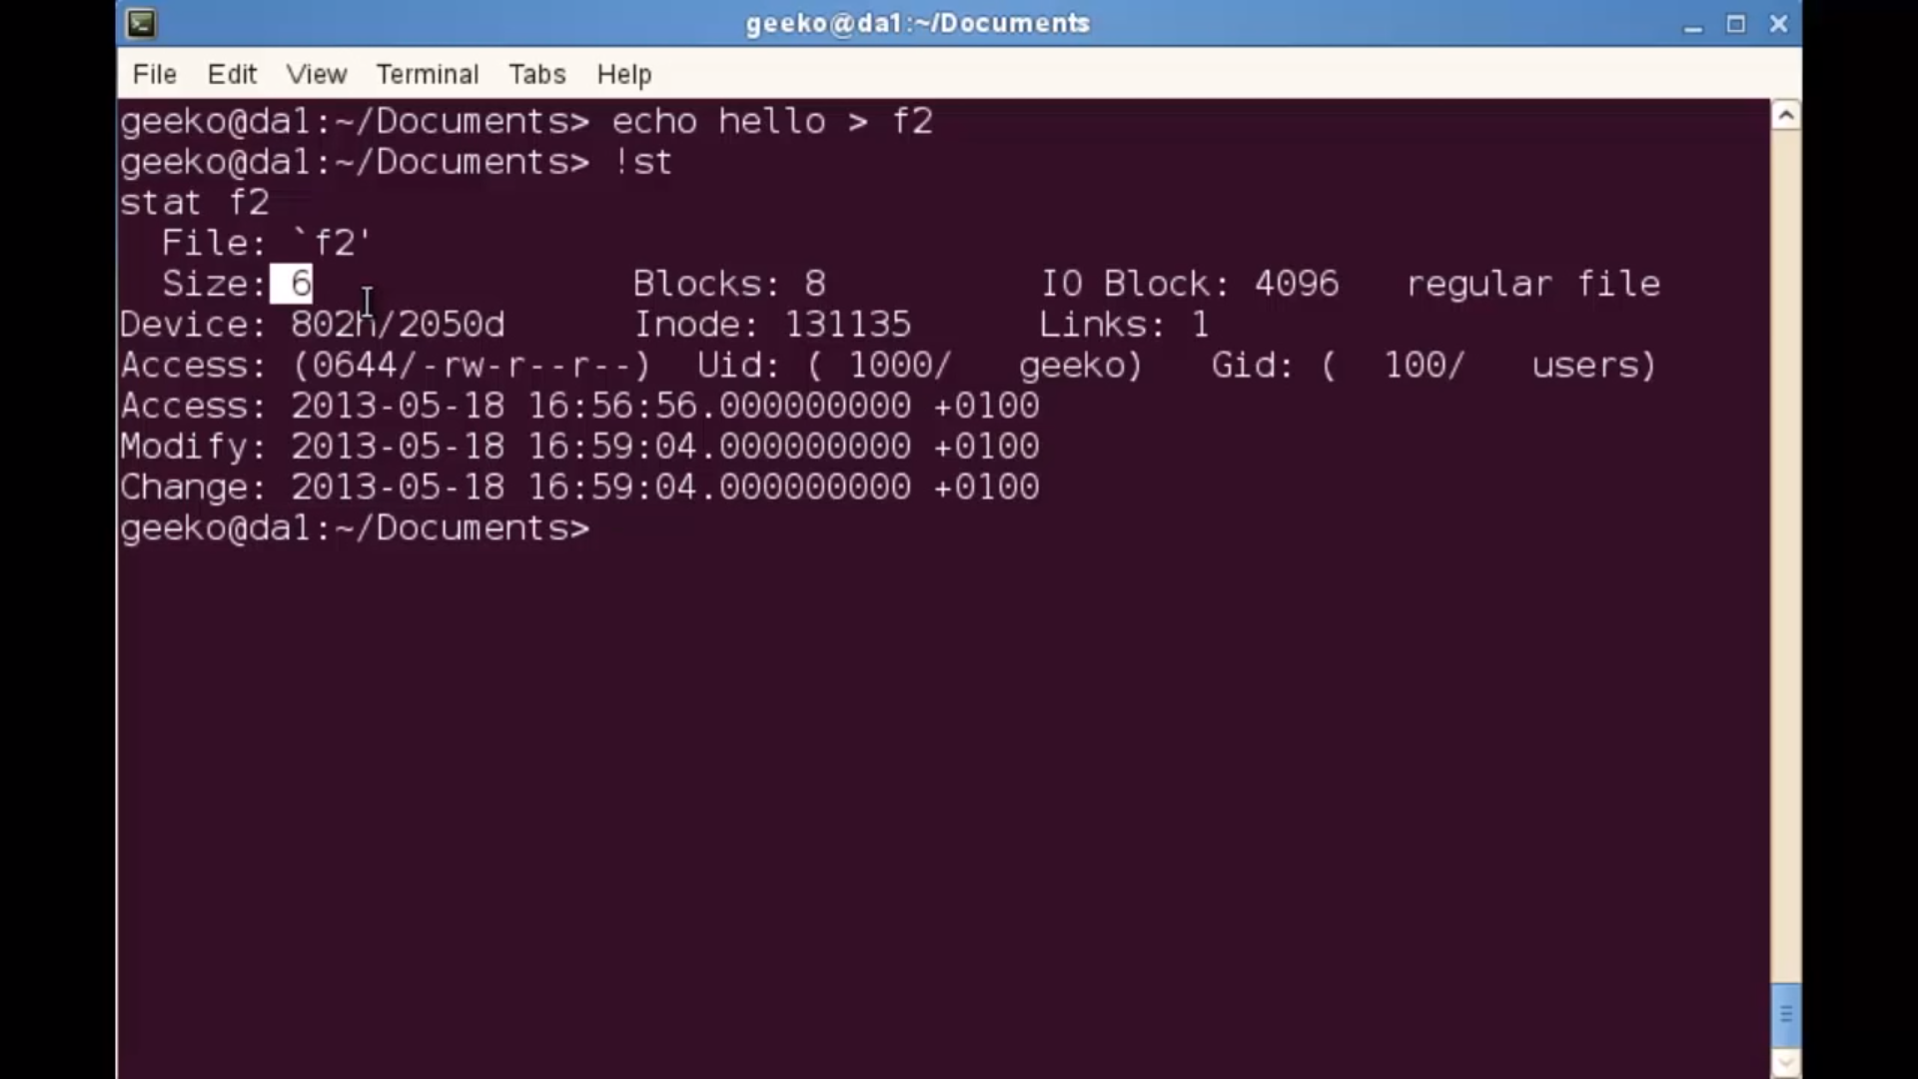

Delete file using Inode number:

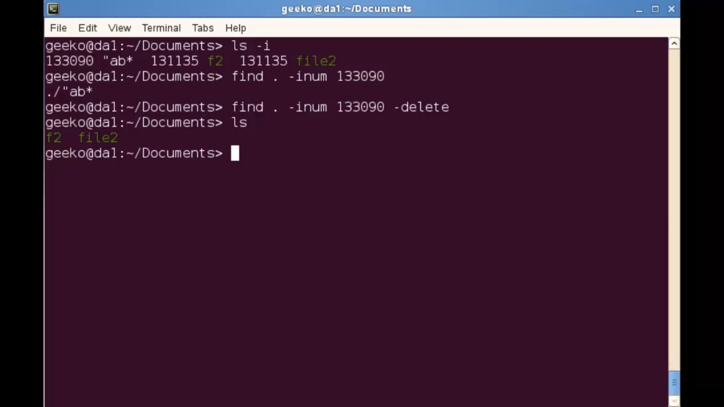

File system: ext2 / ext3 /ext4 /gfs

**Commands**

Ls

Ls –l

Man ls - manual

Ls –help

Su enter – super user login

Passwd username – Change password of username

Mkdir name- create a folder with name name

Su username

Password - change login from current user to username user

**Man –**

/search

q – exit